



| **SUBJECT CODE** | **: SCSJ2154** |
| --- | --- |
| **SUBJECT NAME** | **: OBJECT ORIENTED PROGRAMMING** |
| **YEAR/COURSE** | **: 2 (SCSJ / SCSV / SCSB / SCSR)** |
| **TIME** | **: 1½ Hours** |
| **DATE** | **:** |
| **VENUE** | **:** |

______________________________________________________________________________________

# INSTRUCTIONS :

This test book consists of 2 parts:

Part A: 10 Objective Questions 10 marks

Part B: 5 Questions 40 marks

**ANSWER ALL QUESTIONS IN THE ANSWER BOOKLET.**

**(Please Write Your Lecture Name And Section In Your Answer Booklet)**

| Name |  |
| --- | --- |
| I/C No. |  |
| Year / Course |  |
| Section |  |
| Lecturer Name |  |

# This questions paper consists of ELEVEN ( 11 ) printed pages excluding this page.

**SECTION A: OBJECTIVE QUESTIONS (10 MARKS)**

*Part A consists of 10 objective questions. Choose the best answer, and write your answer in the answer booklet. Each question carries 1 mark.*

1. What is the output of **Program 1**?



| 1. 0.0 | 1. 5.0 |
| --- | --- |
|  |  |
| 1. 6.0 | 1. Compilation Error |

1. Which of these statements are **TRUE**?

|  | 1. Protected methods are final. | | |
| --- | --- | --- | --- |
|  | 1. Private methods cannot be override. | | |
|  | 1. Private methods are final. | | |
|  | 1. Protected members are accessible within a package and inherited classes outside the package. | | |
|  |  | | |
| A. i, ii, iv | | C. i, iii, iv |
| B. i, ii, iii | | D. ii, iii, iv |

1. To prevent any method from being override, method must be declared as,
2. static
3. const
4. final
5. abstract
6. Which of these statements is **TRUE** about polymorphism?
7. It is not supported by Java
8. Refers to the ability of two or more objects belonging to different classes to respond to exactly the different message in different class.
9. Simplifies code maintenance
10. Refers to the ability of two or more objects belonging to different classes to respond to exactly the same message in different class –specific ways and simplifies code maintenance.
11. What is an abstract class?
    1. An abstract class is one without any child classes.
    2. An abstract class is any parent class with more than one child class.
    3. An abstract class is a class which cannot be instantiated, but can be a base class.
    4. abstract class is another name for "base class".
12. Which of the following statement is **TRUE** for a concept of abstract?
13. A subclass can be abstract even if its superclass is concrete
14. An abstract method can be contained in a non-abstract class
15. All the abstract methods do not have to be implemented when they are not used in the subclass
16. A subclass is not allowed to override a method from its superclass

Question 7 and 8 are based on the UML class diagram in Figure 1.

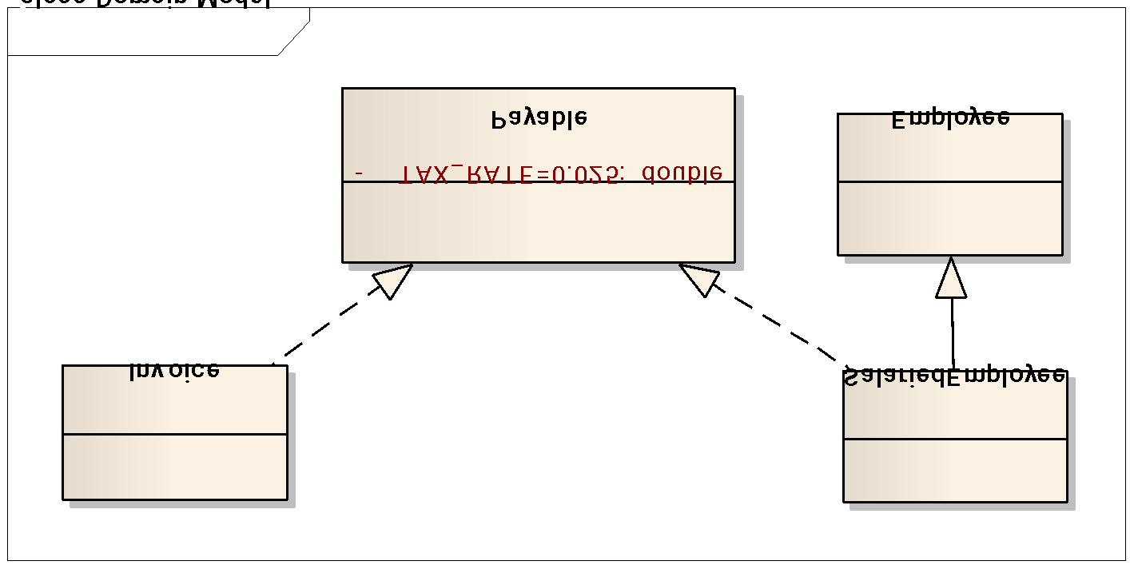



1. Which of the followings is correct in describing **tax_rate** in class **Payable**?
   1. It is final and static.
   2. It has private access.
   3. It has protected access.
   4. It must be initialized in class Invoice and SalariedEmployee.
2. The header for the definition of **SalariedEmployee** class is
   1. **public class SalariedEmployee extends Payable, Employee**
   2. **public class SalariedEmployee implements Payable, Employee**
   3. **public class SalariedEmployee extends Employee implements Payable**
   4. **public class SalariedEmployee implements Employee extends Payable**
3. Which of the following JAVA reserve words which relate to Exception Handling are suitable to be filled in the blanks?



| A. | try , catch |  | C. | try, finally |
| --- | --- | --- | --- | --- |
| B. | throws, throw |  | D. | throw, throws |

1. What will happen when **Program 2** is compiled and run?



| A. | The word “Finally” will be displayed. |
| --- | --- |
| B. | Compilation fails. |
| C. | The code runs with no output. |
| D. | An exception is thrown at runtime. |

**SECTION B: STRUCTURED QUESTIONS (40 MARKS)**

*Part B consists of 5 structured questions. Answer all questions in the answer booklet. The marks for each part of the question is as indicated.*

**Question 1 [9 marks]**

1. The source codes in **Program 3** shows compile time error. Identify the statement that causing the error (give the line number). Explain the reason. (3 marks)

| 1.  2.  3.  4.  5.  6.  7.  8.  9.  10.  11.  12.  13.  14.  15 | **//Program 3**  class Toyota  {  //Class Toyota Members  }  class Altis  {  //Class Altis Members  }  class Vios extends Toyota, Altis  {  //Class Vios Members  } |
| --- | --- |

b. The source code in **Program 4** shows compile time error. Rewrite the program with the correction to the error. (3 Marks)



**.**

1. Give the output of **Program 5** below. (3 marks)



**Question 2 [6 marks]**

Based on **Program 6**, answer the following questions.

| 1  2  3  4  5  6  7  8  9  10  11  12  13  14  15  16  17  18  19  20  21  22  23  24  25  26 | **//Program 6**  class Concept1 {  public void tryMethod() {  System.out.println("Calling 1" );  }  public void tryMethod(int a) {  System.out.println("Calling 2, a: " + a);  }  }  class Concept2 extends Concept1 {  public void tryMethod(int b) {  System.out.println("Calling 3, b: " + b);  }  public void tryMethod(double a) {  System.out.println("Calling 4, a: " + a);  }  }  class TestConcepts {  public static void main(String[] args) {  Concept2 ob = new Concept2();  double i = 7.0;  ob.tryMethod();  ob.tryMethod(15);  ob.tryMethod(i);  }  } |
| --- | --- |

1. Identify which concept applied in tryMethod( ) function at line 11 of **Program 6** (overloading or overriding?). Justify your answer. (1.5 marks)
2. Which concept applied in tryMethod( ) at line 24 of **Program 6** (overloading or overriding?). Justify your answer. (1.5 marks)
3. Give the output of **Program 6.** (3 marks)

**Question 3 [8 marks]**

The following programs in **Card.java**, **Invitation.java** and **Festival.java** demonstrate the abstract concept. There are 4 errors in the programs. Rewrite the errors and its correct statements in a table format as exemplified in Table 1.

| 1  2  3  4  5  6  7  8  9  10  11  12 | // File: Card.java  public abstract superclass Card  {  private String receiver;  public Card () {}  public Card (String r)  { receiver = r; }  public String getReceiver ()  { return receiver; }  public abstract void wishes () {}  } |
| --- | --- |

| 1  2  3  4  5  6  7  8  9  10  11  12  13  14  15 | // File: Invitation.java  class Invitation extends Card  {  private int age;  public Invitation (String rec, int a) {  superclass (rec);  age = a;  }    public void wishes () {  System.out.println("Special for: " +getReceiver());  System.out.println("Happy Birthday. Sweet" +age);  }  } |
| --- | --- |

| 1  2  3  4  5  6  7  8  9  10  11  12  13  14  15 | // File: Festival.java  class Festival extends Card  {    public Festival (String rec) {  super (rec);  }    public abstract void wishes () {  System.out.println("Special for: " +getReceiver());  System.out.println("Greetings on your Special Day");  }  } |
| --- | --- |

**Table 1**

| **File** | **Line of Error** | **Error Statement** | **Corrected Statement** |
| --- | --- | --- | --- |
|  |  |  |  |

**Question 4 [9 marks]**

You are given a UML class diagram in Figure 2. Complete the following program for class **Discount, UTM_Member** and **Student** by answering questions a) to d).

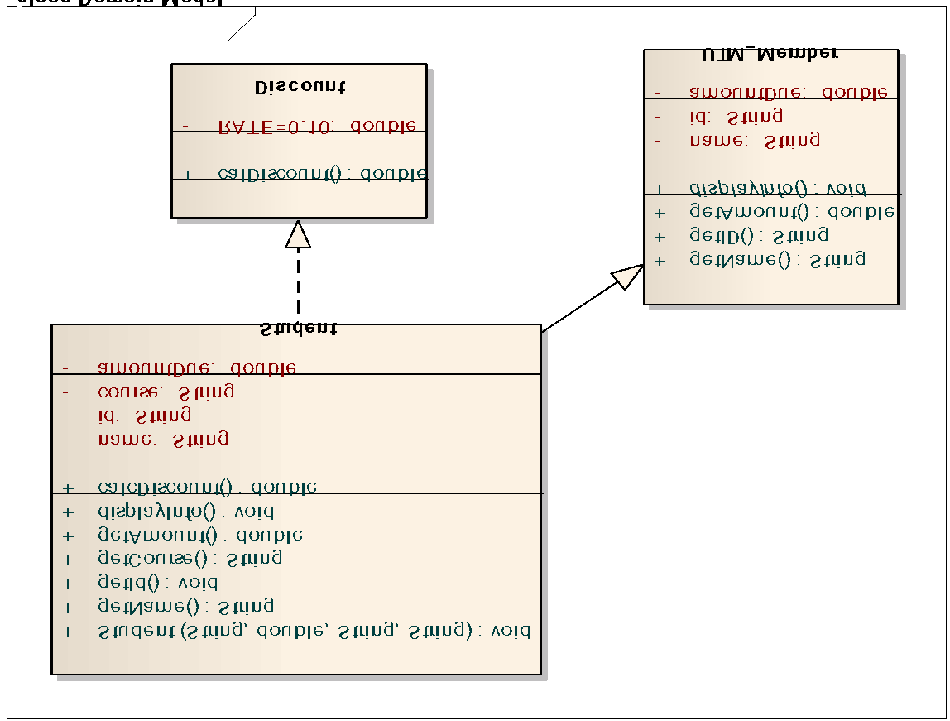







e) What will happen if method **calcDiscount()**is not overridden in class **Student**?

(2 marks)

**Question 5 [8 marks]**

Answer question (i) to (v) as in **Program 7** below with suitable codes to produce output as in Figure 3.

| **//Program 7**  public class TestException {  public static void main (String args[]) {  int array[]={20,20,40};  int num1=15,num2=0;  int result=10;  __(i)_ {  result = num1/num2;  System.out.println("The result is" +result);  for(int i =5;i >=0; i--) {  System.out.println("The value of array is"  +array[i]);  }  }  ____(ii)____(______(iii)_________ ex) {  System.out.println("Array is out of Bounds”);  }  ____(iv)____(_______(v)_________ ex) {  System.out.println ("Can't divide by Zero");  }  }  } |
| --- |

